**STAT 3124**

**Quiz 1**

**212137**

* 1. Time series plot

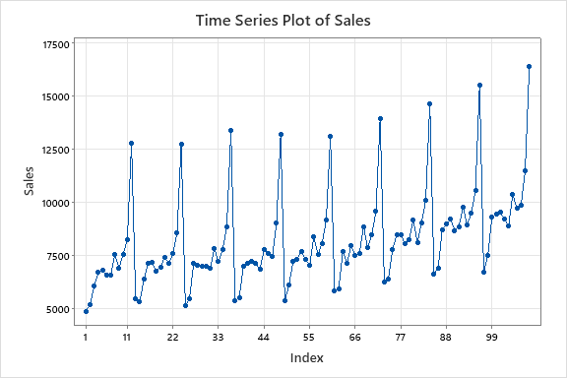

* 1. This time series plot exhibits a seasonal pattern with an upward trend.
  2. Autocorrelation Function

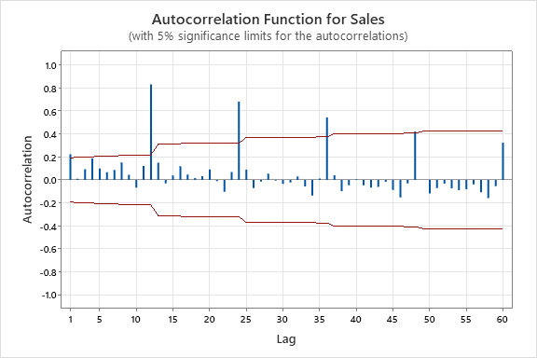

Autocorrelations

Lag ACF T LBQ

1 0.224179 2.33 5.58

2 0.011058 0.11 5.59

3 0.092695 0.92 6.57

4 0.185805 1.83 10.51

5 0.099326 0.95 11.65

6 0.067212 0.64 12.17

7 0.086796 0.82 13.06

8 0.152932 1.43 15.84

9 0.044287 0.41 16.07

10 -0.067845 -0.62 16.63

11 0.121508 1.11 18.44

12 0.831281 7.52 103.95

24 0.682681 4.21 178.58

36 0.543957 2.88 233.68

48 0.421836 2.05 279.19

60 0.324552 1.50 323.46

ACF cuts off at lag 1 in non-seasonal area and ACF cuts off at lag 4 in seasonal area.

Therefore, this series is non-stationary.

* 1. ACF Cuts off at non-seasonal lag 1 and ACF cuts off at seasonal lag 4. In seasonal area it is a slowly dies down pattern.

Therefore, this series is non-stationary.

We have to do a seasonal difference to convert this series into stationary.

* 1. 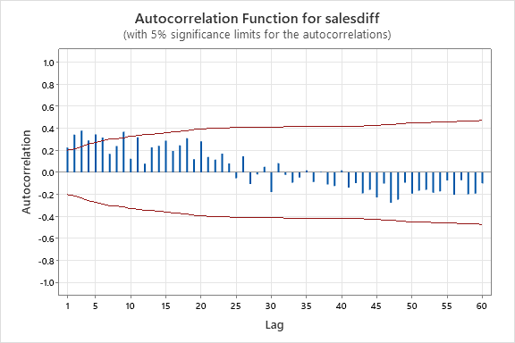Seasonal Difference

Autocorrelations

Lag ACF T LBQ

1 0.225433 2.21 5.03

2 0.342243 3.19 16.76

3 0.379609 3.22 31.33

4 0.289741 2.23 39.92

5 0.344255 2.52 52.17

6 0.316794 2.18 62.66

7 0.168239 1.10 65.65

8 0.239054 1.55 71.76

9 0.370205 2.34 86.58

10 0.123834 0.74 88.26

11 0.318828 1.90 99.51

12 0.078582 0.45 100.20

24 0.080351 0.39 166.11

36 -0.087838 -0.42 179.81

48 -0.247308 -1.11 238.40

60 -0.099170 -0.42 306.83

There is a slowly dies down pattern in non-seasonal area.

Therefore, this series is non-stationary.

We have to do a trend difference to convert this series into stationary series.

Trend Difference

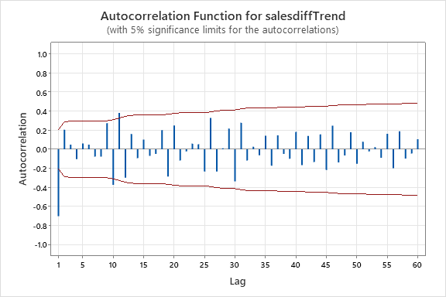

Autocorrelations

Lag ACF T LBQ

1 -0.701880 -6.80 47.80

2 0.205454 1.41 51.94

3 0.048109 0.32 52.17

4 -0.103466 -0.70 53.24

5 0.061590 0.41 53.63

6 0.047930 0.32 53.87

7 -0.076535 -0.51 54.47

8 -0.076962 -0.51 55.09

9 0.274547 1.82 63.10

10 -0.372630 -2.39 78.01

11 0.380738 2.31 93.77

12 -0.298435 -1.71 103.58

24 0.051828 0.27 134.20

36 -0.173278 -0.79 206.99

48 -0.064183 -0.27 258.31

60 0.106454 0.44 303.06

ACF cuts off at non-seasonal lag 1 and other significant values in non-seasonal area, we can consider these values as spike values.

Therefore, this series is stationary.

* 1. .

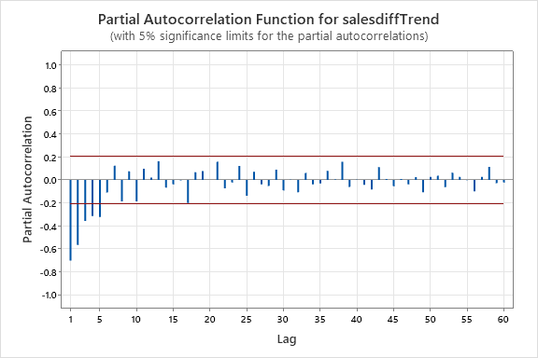

Partial Autocorrelations

Lag PACF T

1 -0.701880 -6.80

2 -0.566028 -5.49

3 -0.357727 -3.47

4 -0.315445 -3.06

5 -0.323551 -3.14

6 -0.109703 -1.06

7 0.124568 1.21

8 -0.186622 -1.81

9 0.075105 0.73

10 -0.185933 -1.80

11 0.097970 0.95

12 0.019924 0.19

24 0.120823 1.17

36 0.079547 0.77

48 0.023461 0.23

60 -0.022646 -0.22

PACF cuts of at non-seasonal lag 5.

* 1. Tentative model

p = cuts off lag value in PACF in non-seasonal = 0

d = no. of trend differences = 1

q = cuts off lag value in ACF in non-seasonal = 1

P = cuts off lag value in PACF in seasonal = 0

D = no. of seasonal differences = 1

Q = cuts off lag value in ACF in seasonal = 0

S = seasonal length = 12

Tentative model

SARIMA (0,1,1)(0,1,0)12

* 1. Final Estimates of Parameters

Type Coef SE CoeF T-Value P-Value

MA 1 0.9207 0.0398 23.14 0.000

Constant 4.74 2.40 1.98 0.051

Significance of the parameters,

H0 : all coefficient = 0

H1 : all coefficient ≠ 0

p- values < 0.05

Therefore, null hypothesis is rejected.

Therefore, we do not have to revised the model.

* 1. Randomness of the residuals

**Modified Box-Pierce (Ljung-Box) Chi-Square Statistic**

|  |  |  |  |  |
| --- | --- | --- | --- | --- |
| **Lag** | **12** | **24** | **36** | **48** |
| Chi-Square | 22.09 | 36.67 | 71.39 | 100.47 |
| DF | 10 | 22 | 34 | 46 |
| P-Value | 0.015 | 0.026 | 0.000 | 0.000 |

* 1. .
  2. Normality of the residuals

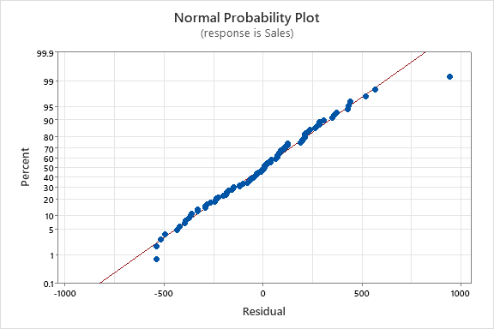

* 1. Final model for the dataset.

SARIMA (0,1,1)(0,1,0)12